EMERGENCY CALL MANAGEMENT SYSTEM
Programming Fundamentals (PF) – Semester 1
Submitted by:
Pernia Ali(25-CS-073)
Ayesha Shahzadi(25-CS-198)
Aiman Hafeez (25-CS-054)
Submitted to:
Sir Mohsin Shahzad
Department of Computer Science

ABSTRACT
The Emergency Call Management System is a console-based application designed to manage emergency calls efficiently. The main purpose of this system is to store and retrieve caller information, including name, phone number, location, emergency type, and priority. The system is admin-controlled, allowing the user to add, view, search, edit, and delete calls. File handling is used for permanent storage of data. This project demonstrates the practical implementation of Programming Fundamentals concepts like structures, arrays, functions, and file handling.

INTRODUCTION
In emergencies, quick response is crucial. Manual handling of calls can be slow and prone to errors. This project automates the management of emergency calls, allowing admins to store, retrieve, and update information efficiently. It provides a clear, easy-to-use interface to manage emergencies while reinforcing our understanding of programming fundamentals.

OBJECTIVES
• To develop a menu-driven emergency call system
• To store emergency call records permanently using file handling
• To practice using structures, arrays, and functions in C++
• To improve logical thinking and problem-solving skills
• To provide a reliable system for managing emergency calls

SCOPE OF THE PROJECT
Suitable for small-scale emergency call centers. Can be extended to include GUI-based interfaces and database support. Ensures emergency information is stored safely and can be retrieved quickly.

TOOLS AND TECHNOLOGIES USED
• Programming Language: C++
• Compiler: Dev-C++
• Platform: Windows
• Concepts Used: Structures, Arrays, Functions, File Handling, Conditional Statements, Loops, Console formatting & colors

SYSTEM DESIGN
The system is menu-driven and starts with admin login for security. After logging in, the admin can perform the following operations:
• Add new emergency calls
• View all call records
• Search for a call by phone number
• Edit existing calls
• Delete calls
• View call statistics
• Sort calls by name
• Backup data
• Restore data
All data is stored in a text file to ensure it is available even after the program is closed. Timestamp is added automatically for each record.
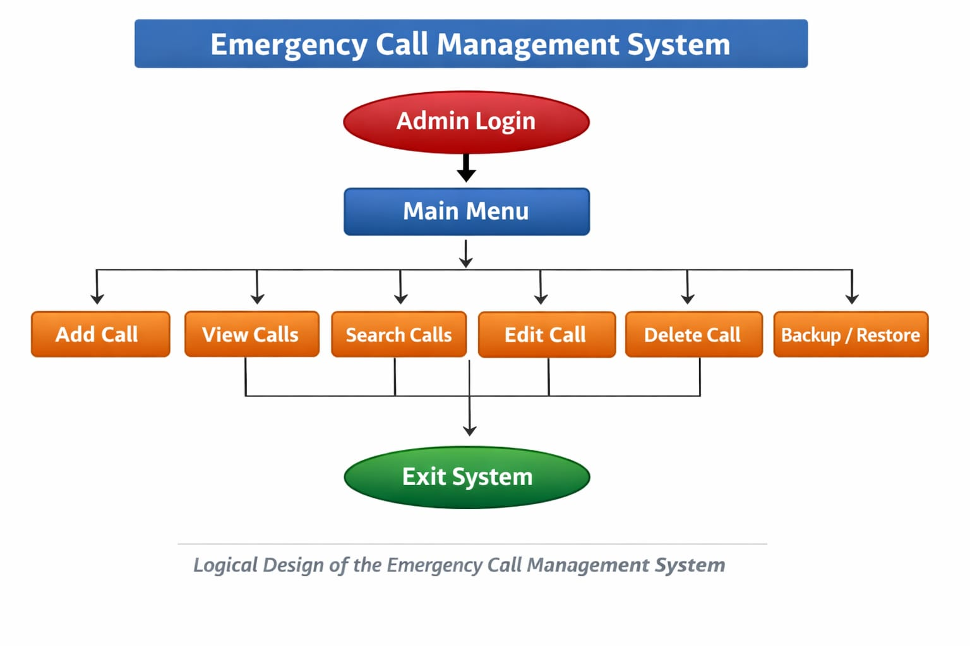

MODULE DESCRIPTION

Add Emergency Call Module
This module allows the admin to add a new emergency call. It collects the caller's name, phone number, location, type of emergency, and priority. The call is then saved to a file with a timestamp.

View Calls Module
This module displays all saved emergency calls in a tabular format. Color coding is used to indicate priority: Critical → Red, High → Yellow, Medium → White, Low → Green.

Search Call Module
The admin can search for a call using the phone number. If found, the call details are displayed with the appropriate color coding.

Edit Call Module
Allows the admin to modify existing call details. Data validation ensures that phone numbers are 10 digits and names are not too long. The timestamp is updated automatically after editing.

Delete Call Module
The admin can delete a call by entering the phone number. The system shifts remaining records to maintain array continuity and updates the file.

Statistics Module
Shows total number of calls and number of Fire, Medical, and Police calls.

Sort Calls by Name Module
Allows the admin to sort call records alphabetically by the caller's name.

Backup & Restore Module
Backup creates a copy of all records in a separate file. Restore replaces current data with the backup file.

INPUT AND OUTPUT
Input: Name, Phone, Street, Society, City, Type, Priority, date and Time.
INPUT AND OUTPUT
Input
The system takes the following details from the admin while registering an emergency call:
- Caller Name
- Phone Number
- Street
- Society
- City
- Emergency Type (Fire / Medical / Police)
- Priority Level (High / Medium / Low)
- Priority helps the admin decide which emergency call needs immediate attention.
Output
The output is displayed in a proper tabular format for better readability and management of emergency records.

LIMITATIONS
• Only supports Windows due to windows.h usage
• Multi-word input (like 'Ali Khan') may require underscores
• Console-based interface only
• Single admin login only

CONCLUSION
This project demonstrates the practical use of Programming Fundamentals concepts. It provides a secure, reliable, and easy-to-use emergency call management system. The project helps understand file handling, arrays, structures, and functions in C++. Future enhancements can include GUI, multiple users, and database integration.

FUTURE ENHANCEMENTS
• Graphical User Interface (GUI)
• Multi-admin accounts
• Real-time database integration
• SMS notifications for emergencies
• Cloud storage for call records
--------------------------------------------------------------------------------------------------------------------------------

